**Lab 02:**

**Static Web Design using HTML**



**Spring 2023**

[**CSE-403L**](https://classroom.google.com/u/0/c/NTk1NjYwNDQzNzky) **DBMS Lab**

Submitted by: **Mosaddiq Billah**

Registration No.: **20PWCSE1863**

Class Section: **A**

“On my honor, as student of University of Engineering and Technology, I have neither given nor received unauthorized assistance on this academic work.”

Student Signature:

Submitted to:

**Ma’am Sumayyea Salahuddin**

Friday, March 10th, 2023

**Department of Computer Systems Engineering**

**University of Engineering and Technology, Peshawar**

**---------------------------Task 2.2---------------------------**

**Forms play critical role in taking data to and from users. To enhance this ability, design three different types of forms using HTML Form. (Note: Don’t use CSS or Bootstrap. Only HTML.) Example forms can be registration form, contact form, student feedback form, etc.**

**Code**

**Form 1**

<head>

    <title>TASK2</title>

</head>

<center><body background="f1c03dbd67a6af703d8e25b2e1078750.png">

    <h1>Know Your Meme</h1>

        <label>Name:</label>

        <input type="text" ><br>

        <label>Email:</label>

        <input type="email"><br>

        <label>Password:</label>

        <input type="password"><br>

        <label>Category</label><br>

        <input type="radio"> Wholesome Memes<br>

        <input type="radio"> Dank Memes<br>

        <input type="radio"> Student Memes<br>

        <input type="radio"> Depression Memes<br>

        <input type="submit" value="Register">

      </form>

</body></center>

</html>

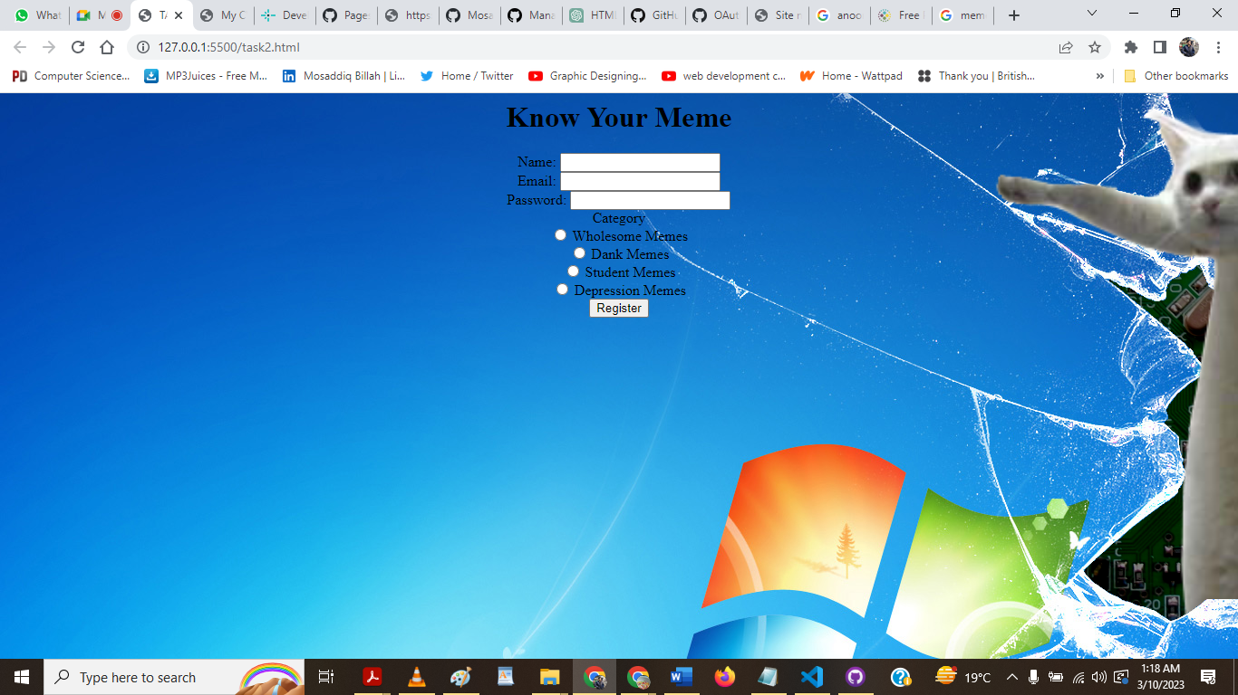

**Form 2**

<html lang="en">

<head>

    <meta charset="UTF-8">

    <meta http-equiv="X-UA-Compatible" content="IE=edge">

    <meta name="viewport" content="width=device-width, initial-scale=1.0">

    <title>Document</title>

</head>

<body>

    <center><h1> Feedback Form</h1></center>

   <center> <form>

  <label for="name">Name:</label>

  <input type="text" name="name" required> <br> <br>

  <label for="email">Email:</label>

  <input type="email" name="email" required> <br> <br>

  <label for="course">Course:</label>

  <input type="text" name="course" required> <br> <br>

  <label for="feedback">Feedback:</label>

  <textarea  name="feedback" required></textarea> <br> <br>

  <label for="rating">Rating:</label>

  <input type="range"  name="rating" min="1" max="5" required> <br> <br>

  <input type="submit" value="Submit">

</form> </center>

</body>

</html>

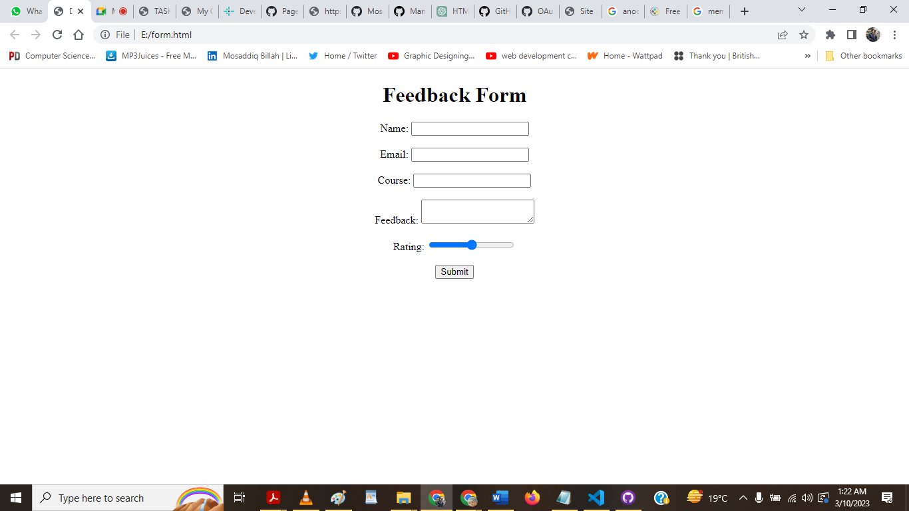

**Form 3**

<!DOCTYPE html>

<html lang="en">

<head>

    <meta charset="UTF-8">

    <meta http-equiv="X-UA-Compatible" content="IE=edge">

    <meta name="viewport" content="width=device-width, initial-scale=1.0">

    <title>Document</title>

</head>

<body>

    <center><h1> Contact Form</h1></center><br>

   <center> <form>

        <label for="name">Name:</label>

        <input type="text" id="name" name="name" required><br><br>

        <label for="email">Email:</label>

        <input type="email" id="email" name="email" required><br><br>

        <label for="subject">Subject:</label>

        <input type="text" id="subject" name="subject" required><br><br>

        <label for="message">Message:</label>

        <textarea id="message" name="message" required></textarea><br><br>

        <input type="submit" value="Submit">

      </form>

    </center>

</body>

</html>

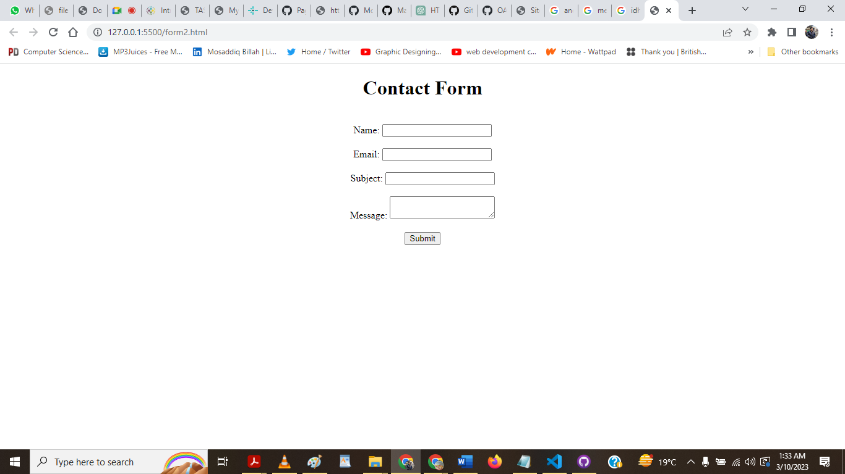

**---------------------------Task 2.3---------------------------**

**Write the HTML code that generates the table given in Figure 2.16 (hint: use align attribute for cell alignment and set table width to 400 pixels):**

**Code**

<html>

<head>

    <title>Document</title>

</head>

<center><body bottommargin="center">

    <table width="400px" border="1">

        <thead bgcolor="seagreen">

          <tr>

            <th>Rank</th>

            <th>Country</th>

            <th>US$</th>

            <th>Year</th>

          </tr>

        </thead>

        <tbody>

          <tr>

            <td>1</td>

            <td>

              <img src="Flag-Luxembourg.webp" width="20">

              Luxembourg

            </td>

            <td>21.44 trillion</td>

            <td>2011</td>

          </tr>

          <tr>

            <td>2</td>

            <td>

              <img src="Flag-Qatar.webp" width="20">

              Qatar

            </td>

            <td>14.14 trillion</td>

            <td>2011</td>

          </tr>

          <tr>

            <td>3</td>

            <td>

              <img src="Flag-Norway.webp" width="20">

              Norway

            </td>

            <td>5.15 trillion</td>

            <td>2011</td>

          </tr>

          <tr>

            <td>4</td>

            <td>

              <img src="Flag-Switzerland.webp" width="20">

              Switzerland

            </td>

            <td>5.15 trillion</td>

            <td>2011</td>

          </tr>

          <tr>

            <td>5</td>

            <td>

              <img src="Flag_of_the_United_Arab_Emirates.svg.png" width="20">

              UAE

            </td>

            <td>5.15 trillion</td>

            <td>2011</td>

          </tr>

          <tr>

            <td>6</td>

            <td>

              <img src="Flag-Australia.webp" width="20">

              Australia

            </td>

            <td>5.15 trillion</td>

            <td>2011</td>

          </tr>

          <tr>

            <td>7</td>

            <td>

              <img src="Flag-Denmark.webp" width="20">

              Denmark

            </td>

            <td>5.15 trillion</td>

            <td>2011</td>

          </tr>

        </tbody>

        <tr>

            <td>8</td>

            <td>

              <img src="Flag_of_Sweden.svg.png" width="20">

              Sweden

            </td>

            <td>5.15 trillion</td>

            <td>2011</td>

          </tr>

          <tr>

            <td>9</td>

            <td>

              <img src="Flag_of_Canada_(Pantone).svg" width="20">

              Canada

            </td>

            <td>5.15 trillion</td>

            <td>2011</td>

          </tr>

          <tr>

            <td>10</td>

            <td>

              <img src="flag-prototype-Netherlands-countries-European-flags.webp" width="20">

              Netherlands

            </td>

            <td>5.15 trillion</td>

            <td>2011</td>

          </tr>

      </table>

</body></center>

</html>

**---------------------------Task 2.4---------------------------**

**There are many new features available in HTML 5. Pick at least five features that are not covered in this lab and introduce its usage through detailed examples and description. These features include figure, audio, video, svg, regular expressions, GeoLocation, canvas, article, section, header, footer, drag & drop, form validation, and web sockets.**

1. **Header Tag**

Header tag is used to specify the starting section of a web-page.

1. **Footer Tag**

Footer tag is used to specify the ending section of a web-page.

1. **Video Tag**

Video tag is used to insert a video content in a web-page.

1. **Audio Tag**

Audio tag is used to insert an audio content in a web-page.

1. **Article Tag**

Article tag is used to insert the reading content in text, in a web-page.

<!DOCTYPE html>

<html>

  <head>

    <title>My Website</title>

  </head>

  <body>

    <header>

      <h1>Welcome to my website!</h1>

      <nav>

        <ul>

          <li><a href="#">Home</a></li>

          <li><a href="#">About</a></li>

          <li><a href="#">Contact</a></li>

        </ul>

      </nav>

    </header>

    <main>

        <h1>My Audio Example</h1>

        <audio controls>

          <source src="Anna Clendening - I Dont Even Like You Anymore [Official Video].mp3" type="audio/mp3">

          Your browser does not support the audio element.

        </audio>

        <h1>My Video Example</h1>

        <video controls width="640" height="360">

          <source src="Ariana Grande - Touch It (Lyrics).mp4" type="video/mp4">

          Your browser does not support the video element.

        </video>

        <h1>My SVG Example</h1>

        <article>

          <h2>DBMS</h2>

          <p>DataBase Management Systems is my favourite subject of all!</p>

          </article>

          <article>

          <h2>DBMS LAB</h2>

          <p>DataBase Management Systems Lab is the practical implementation of the theoretical subject!</p>

          </article>

    </main>

    <footer>

      <p>&copy; 2023 My Website. All rights reserved.</p>

    </footer>

  </body>

</html>

